5a razred, engleski jezik, 4.5.-8.5.
Hello everyone!
Podsjećam Vas na vaš zadatak. Trebalo je nacrtati što ste radili jučer, ili preko vikenda. Ovako:
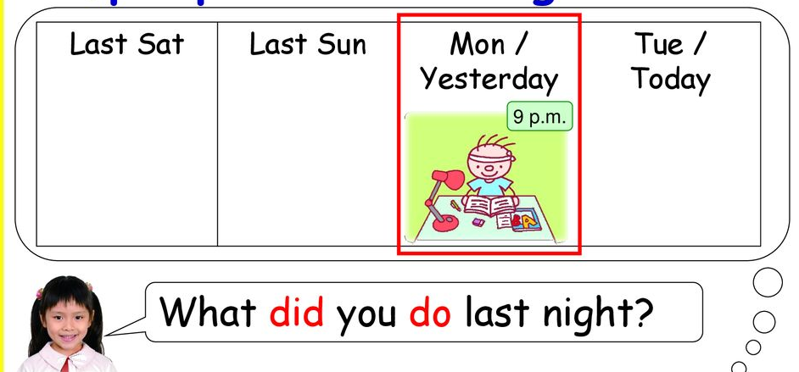
danas today
jučer yesterday
I did my homework. (Radila sam zadaću.)

What did you do last Sunday?
(Što si radila u nedjelju?)
I played football. (Igrala sam nogomet.)
(Igrao sam nogomet.)
(Igrali smo nogomet.)
Prošlo vrijeme u engleskom jeziku ( played) jednako je za sva lica, za jedninu i za množinu.
Jedino moramo razlikovati was i were.
I was at home. We were at home.
She was at home. You were at home.
He was at home. They were at home.

ZADATAK: Pošaljite mi svoje crteže do kraja tjedna. Nacrtajte nešto što ste radili ovaj tjedan.
Uvježbajmo pitanje : Što si radio? What did you do?
Što si radio ovog jutra? What did you do this morning ?
Što si radio jučer? What did you do yesterday?
Što si radio za vikend? What did you do last weekend?

Poslušajte nekoliko puta ovu pjesmicu. Naučite pitanja i odgovore.
https://www.youtube.com/watch?v=ROr2sUv-n6M

Ovo je prvi dio. What did you do this morning? Što si radila ovog jutra.
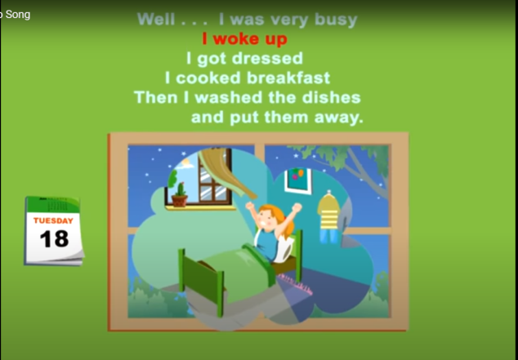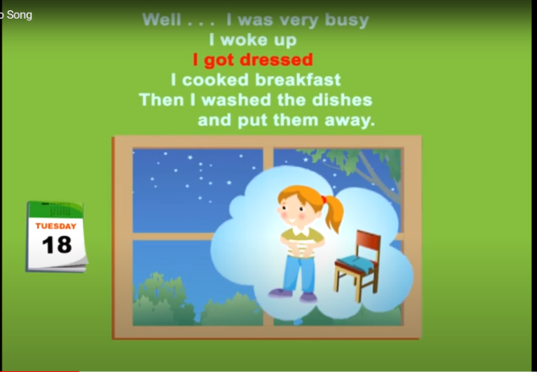
I woke up. Probudila sam se. I got dressed. Obukla sam se.
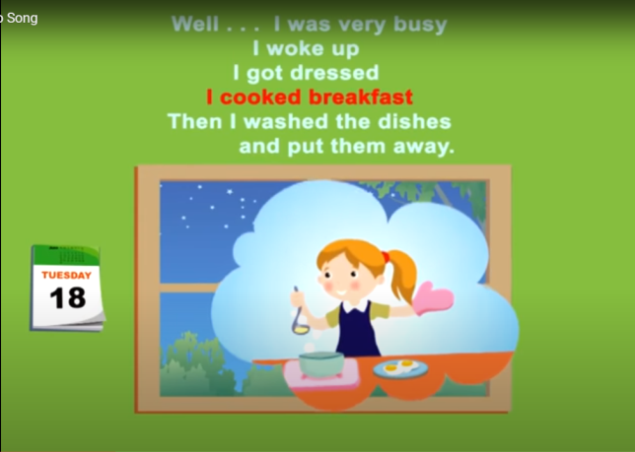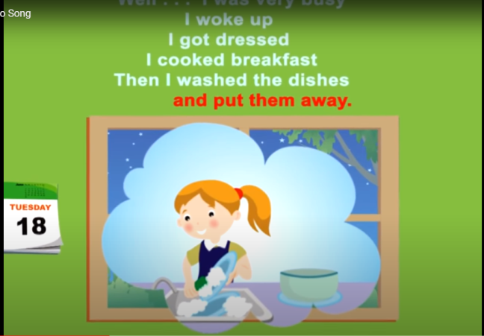
I cooked breakfast. Pripremila sam doručak. I washed the dishes. Oprala sam posuđe.
and I put them away. i pospremila ga.

Da bi izrazili prošlost najčešće treba glagolima dodati slova -ed (dressed, cooked, washed).
Pogledajte ove slike . To je drugi i treći dio pjesmice.

What did she do yesterday? What did she do last weekend?
Što je radila jučer? Što je radila prošlog vikenda.
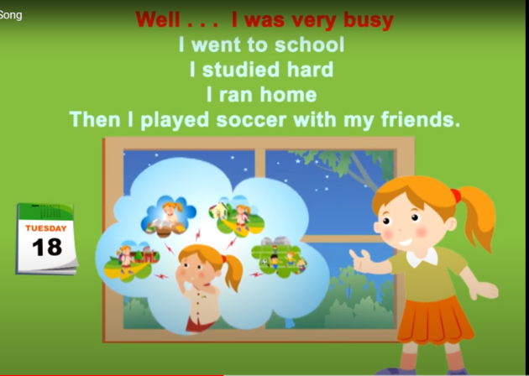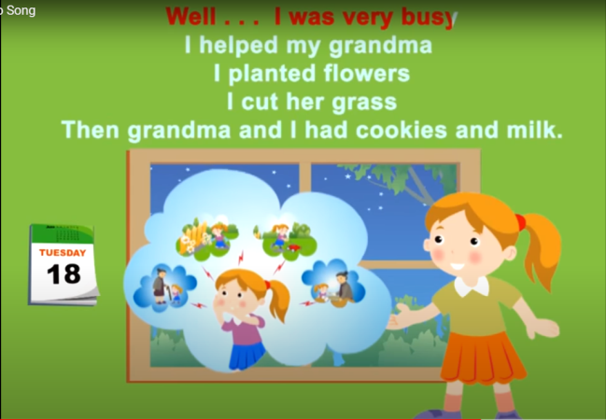

ZADAĆA: Prepiši ova pitanja i odgovore. Označene riječi su glagoli u prošlom vremenu.

What did she do yesterday? What did she do last weekend?
She went to school. She helped her grandma.
She studied hard. She planted flowers.
She ran home. She cut the grass.
She played soccer. She had cookies and milk.

