PROVJERA ZNANJA

1 .POKRAJ SLIKE NAPIŠI RIJEČ ( SLON , MIŠ, LAV , JEŽ, ŠAL )

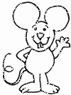 ____________________

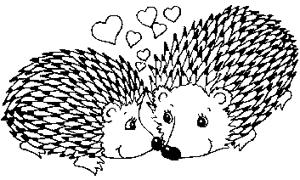 ___________________

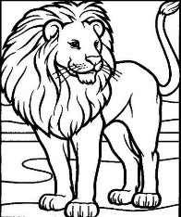 ___________________

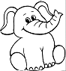 ____________________

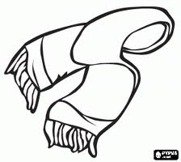 ____________________

2.PREPIŠI VELIKIM TISKANIM SLOVIMA OVE REČENICE :

Ana ima mamu Ivanu.

|  |
| --- |
|  |

Leon voli kekse.

|  |
| --- |
|  |

3.Nacrtaj ono što piše .

|  |
| --- |
| DJECA KITE BOR. |